CHANGES HISTORY
PIC | Date | Remarks
BJM.MR | 2018.05.04 | Created
Ghaida | 2018.05.04

TOC
- Parameter Gl Debit Credit
- Parameter Gl Journal Status
- Parameter Gl Journal Type
- Parameter Gl Journal Account Type
- Parameter Gl Journal Cash Type

Diagram ENTITY RELATIONSHIP

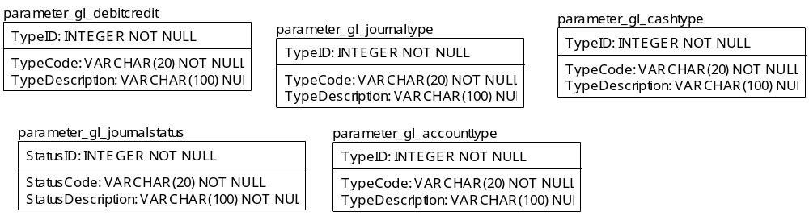

TABLE RELATIONSHIP
No | Table 1 | Table 2 | Type (1:1; 1:N; M:N) | Description

Name |  | parameter_gl_debitcredit
Objective
No | Column |  | Type | Rule  (PK, FK, Key, NN, Unik, Index) | Description
1. | TypeID |  | Integer | NN
2. | TypeCode |  | Varchar(50) | NN
3. | TypeDescription |  | Varchar(100) | Null

SAMPLE DATA
No | Column | Sample 1 | Sample 2 | Sample 3 | Sample 4
1. | TypeID | 1 | 2
2. | TypeCode | DEBIT | CREDIT
3. | TypeDescription | Debit | Credit

Name |  | parameter_gl_journalstatus
Objective
No | Column |  | Type | Rule  (PK, FK, Key, NN, Unik, Index) | Description
1. | StatusID |  | Integer | NN
2. | StatusCode |  | Varchar(20) | NN
3. | StatusDescription |  | Varchar(100) | NN

SAMPLE DATA
No | Column | Sample 1 | Sample 2 | Sample 3 | Sample 4
1. | StatusID | 1 | 2 | 3
2. | StatusCode | ENTRY | POSTED | DELETE
3. | StatusDescription | Entry | Posted | Delete

Name |  | parameter_gl_journaltype
Objective
No | Column |  | Type | Rule  (PK, FK, Key, NN, Unik, Index) | Description
1. | TypeID |  | Integer | NN
2. | TypeCode |  | Varchar(20) | NN
3. | TypeDescription |  | Varchar(100) | Null

SAMPLE DATA
No | Column | Sample 1 | Sample 2 | Sample 3 | Sample 4
1. | TypeID | 1 | 2
2. | TypeCode | INVT | GJ
3. | TypeDescription | Investment Journal | General Journal

Name |  | parameter_gl_accounttype
Objective
No | Column |  | Type | Rule  (PK, FK, Key, NN, Unik, Index) | Description
1. | TypeID |  | Integer | NN
2. | TypeCode |  | Varchar(20) | NN
3. | TypeDescription |  | Varchar(100) | Null

SAMPLE DATA
No | Column | Sample 1 | Sample 2 | Sample 3 | Sample 4
1. | TypeID | 1 | 2 | 3 | 4
2. | TypeCode | ASSET | LIABILITIES | CAPITAL | INCOME
3. | TypeDescription | Asset | Liabilities | Capital | Income

Name |  | parameter_gl_cashtype
Objective
No | Column |  | Type | Rule  (PK, FK, Key, NN, Unik, Index) | Description
1. | TypeID |  | Integer | NN
2. | TypeCode |  | Varchar(20) | NN
3. | TypeDescription |  | Varchar(100) | NN

SAMPLE DATA
No | Column | Sample 1 | Sample 2 | Sample 3 | Sample 4
1. | FieldCode | 1 | 2 | 3
2. | simpiID | OPERATING | INVESTING | FINANCING
3. | FieldType | Operational cashflow | Investment cashflow | Financing cashflow

